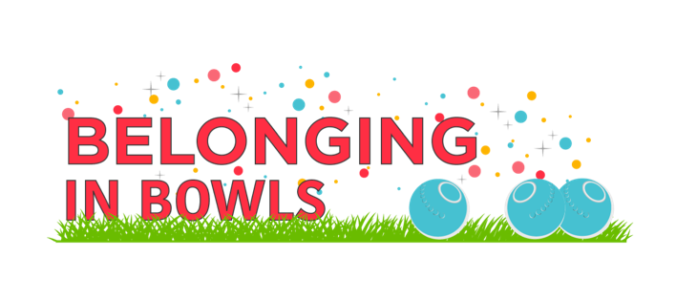
Belonging in Bowls Pledge

Safe Sport Member Pledge:

As a member of the PRESTON LAWN BOWLING CLUB, I pledge to be respectful, friendly, inclusive, and welcoming.

I commit to doing my part to maintain my club’s safe environment by following the club’s code of conduct and respecting the policies of the club.

